

SCHOOL OF COMPUTER SCIENCE AND ENGINEERING
CAT – I
CSE 2004 – Database Management Systems
Course Name: B.Tech Slot: D1 Max. Marks: 50
Answer ALL Questions (5 * 10 = 50)
- a. If you are a database designer in IBM, Describe the physical data models for database and recommend the suitable model to operate on social media data? (5)

- Hierarchical Model
- Network Model
- Relational Model
- ER Model

b. Data Independence is achieved in modern databases using schemas, Exemplify the schema structure to achieve the above?

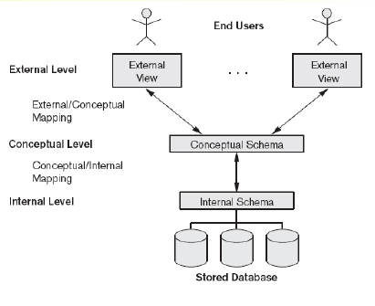

2 If you are a database analyst for Oracle Corporation, as a stake holder of the corporation to train the customers on database environment, list the functionalities and different modules in DB. (10)

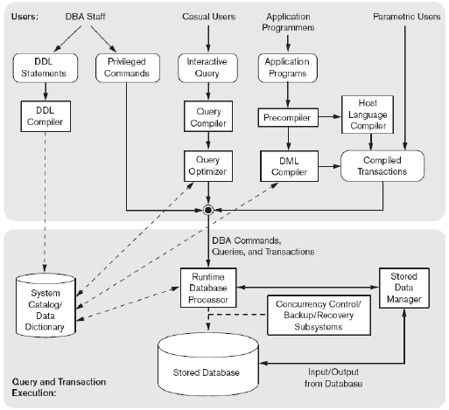

3. Major airlines companies that provide passenger services in Taiwan are: UniAir, TransAsia Airways, Far Eastern Transport, Great China Airlines etc. Taiwan’s Federal Aviation Administration (TFAA) keeps a database with lots of information on all airlines. This information is made accessible to all airlines in Taiwan with the intention of helping the Companies assess their Competitive position in the domestic market. The information kept consists of: Each airpline has an identification number, name of the contact person and telephone number.For each aircraft identification number, capacity and model is recorded.
- Each employee has an employee identification number, name, address, birthday, sex, position with the company and qualification.
- Each route has a route identification number, origin, destination, classification (into domestic or international route), distance of the route and price charged per passenger.
- Each airline keeps information about their buy/sell transactions (for example, selling an airplane ticket is a sell transaction, paying for maintenance is a buy transaction). Each transaction has a transaction identification number, date, description and amount of money paid/received.
  - Design a suitable ER diagram for the above scenario with all possible entities(minimum of eight entities) , attributes and its corresponding relationship.

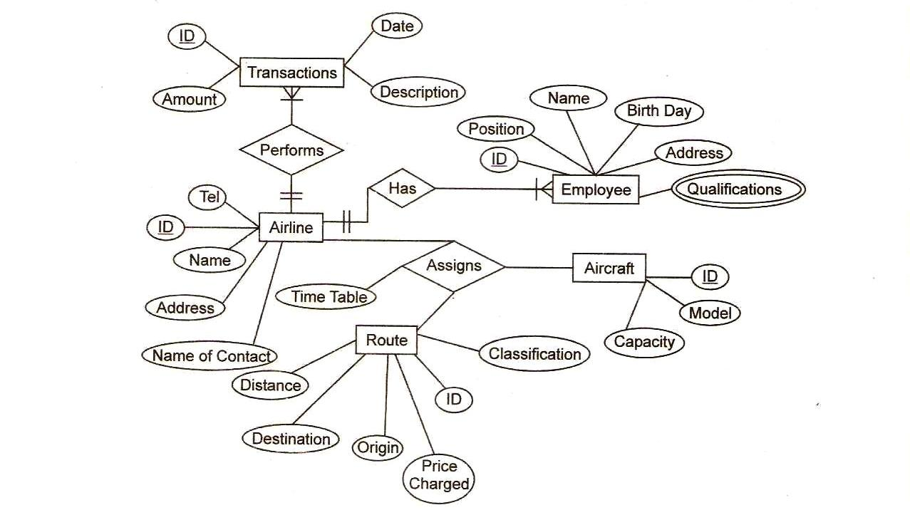
4. a) Answer the following (5)
  - Is it mandatory for a foreign key to be a primary key in another table?
Yes a Foreign key should be a primary key in the parent table
  - Can foreign keys be null values in the child relation? yes
  - After enforcing foreign key constraint using on delete cascade rule, Can you delete the record in the child relation whose foreign key is not null before deleting the record in the parent relation? no
  - Can foreign keys have duplicate values? yes
  - Can there exist more than one foreign key in a relation? yes

b) Reason out why Parent Keys Not Found Error occur during the enforcement of
foreign keys and how will you fix it with a suitable example. (5)

Parent keys not found errors occurs when a value present in the foreign key column is not present in the primary key column of the parent table.

5. Compare primary key, candidate key, super key, and alternate key. From the below tables identify primary key, candidate key, super key, alternate key and justify. (10) 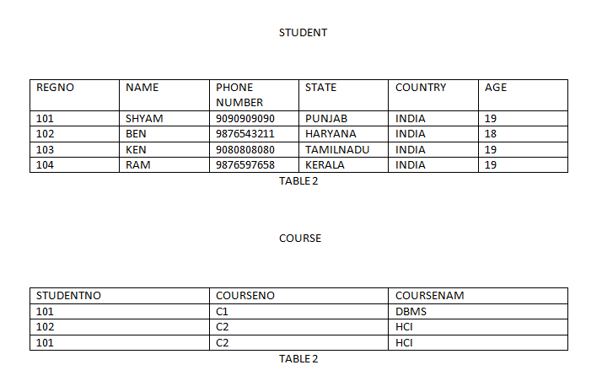

- Key Constraints
  - Candidate Key
    - A column in a table which has the ability to become a primary key.
  - Alternate Key
    - Any of the candidate keys that is not part of the primary key
  - Primary Key
    - The attribute or combination of attributes that uniquely identifies a row or record.
  - Super Key
    - A combination of one or more columns in a table which can be used to identify a record in a table uniquely, a table can have any number of super keys.

